.IOC FILE CONFIGURATION

* SET THE TIMEBASE TO SYSTICK

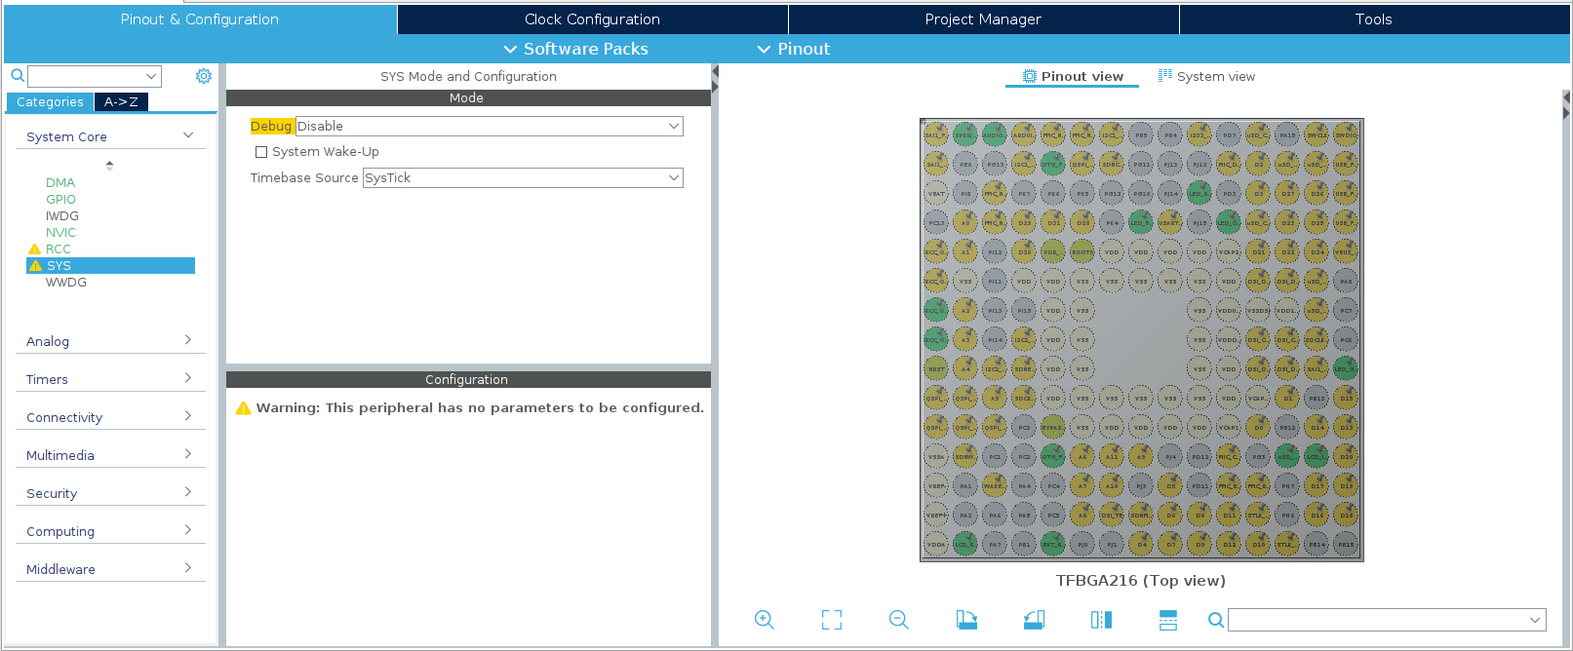

* SET HIGH SPEED CLOCK (HSE) << CRYSTAL/CERAMIC RESONATOR

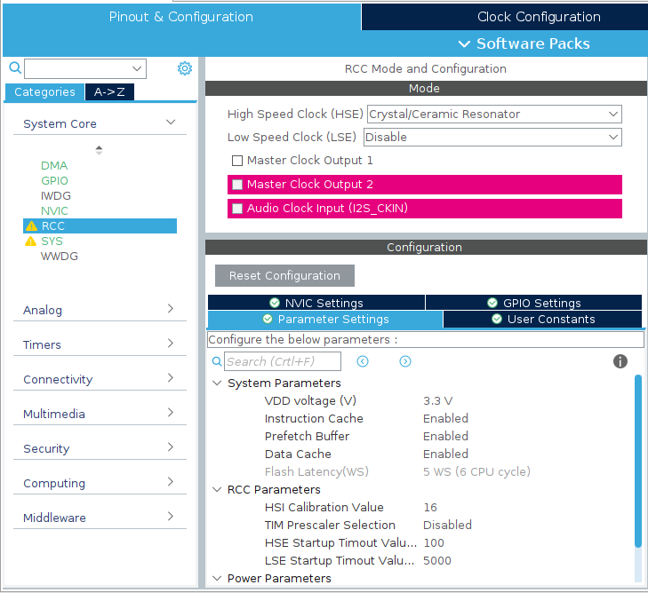

* SET THE GPIO’S (POn), WHERE n DEFINE EACH LED, AND RENAME IT HOW YOU DESIRE

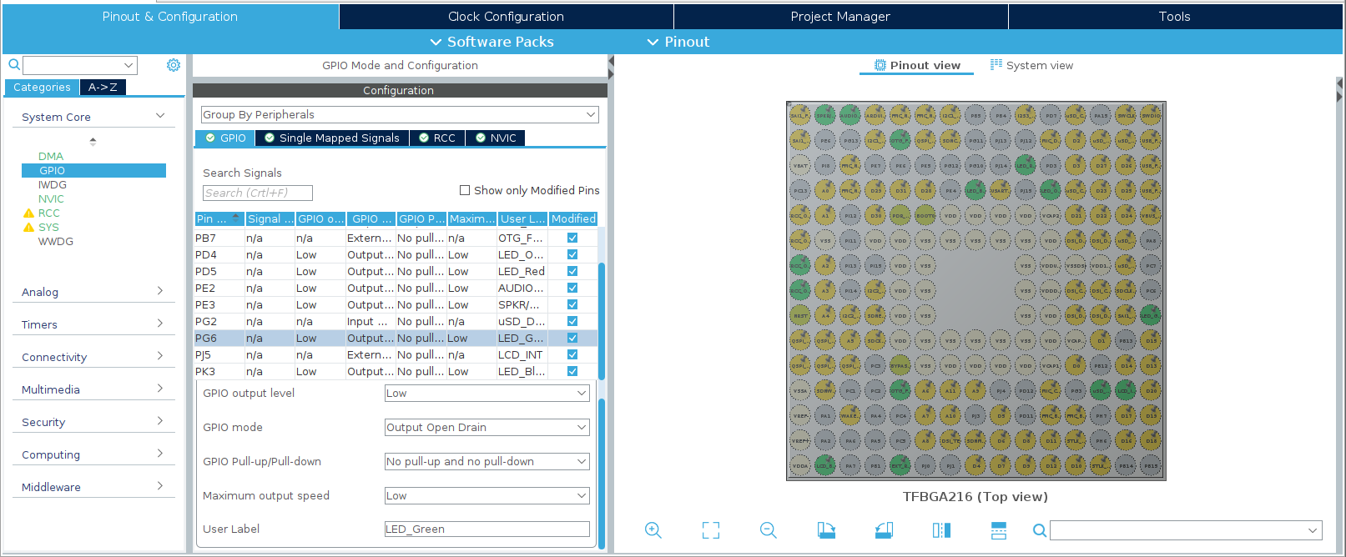

ADC CONFIG:

* ENABLE THE DMA INTERRUPT AND THE CONTINUOS CONVERSION MODE

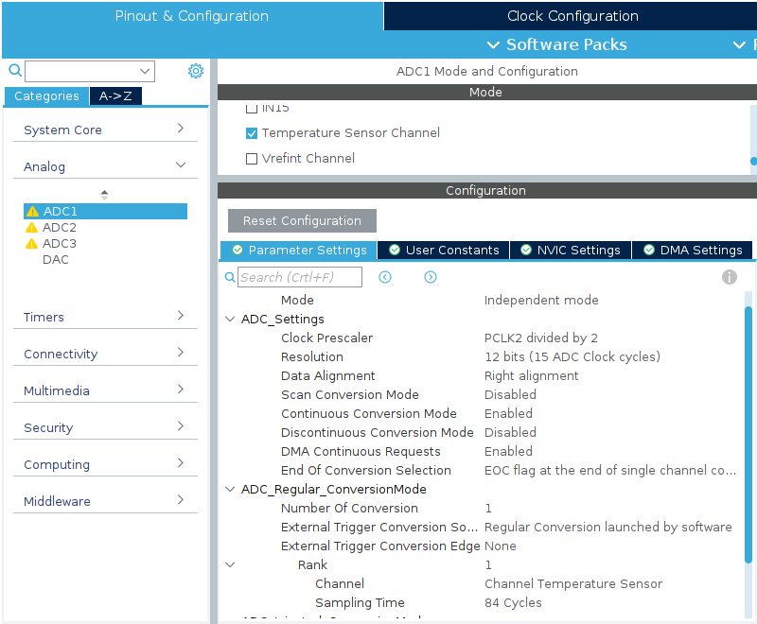

* ON DMA INTERRUPT SET TO CIRCULAR THE MODE O REQUEST

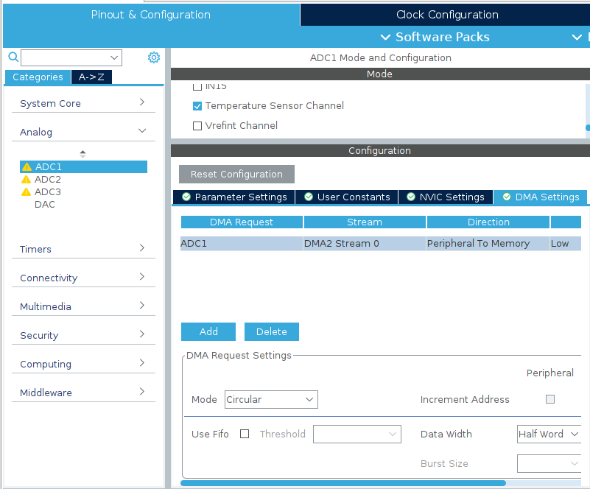

HOW THE CLOCK CONFIGURATION LOOKS LIKE.

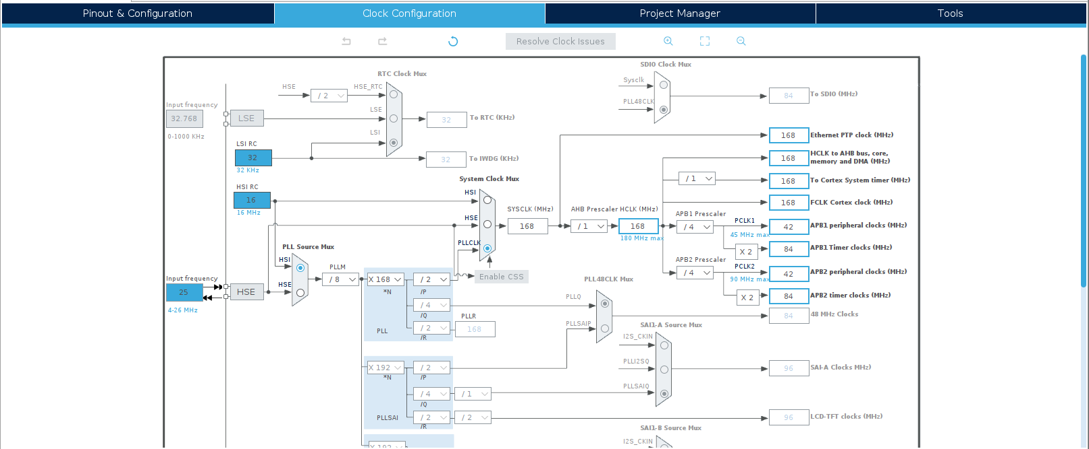

* CHECK THE BOX IN GENERATED FILES TO SEPARATE THE PERIPHERALS ON THE LOCATION PROJECT

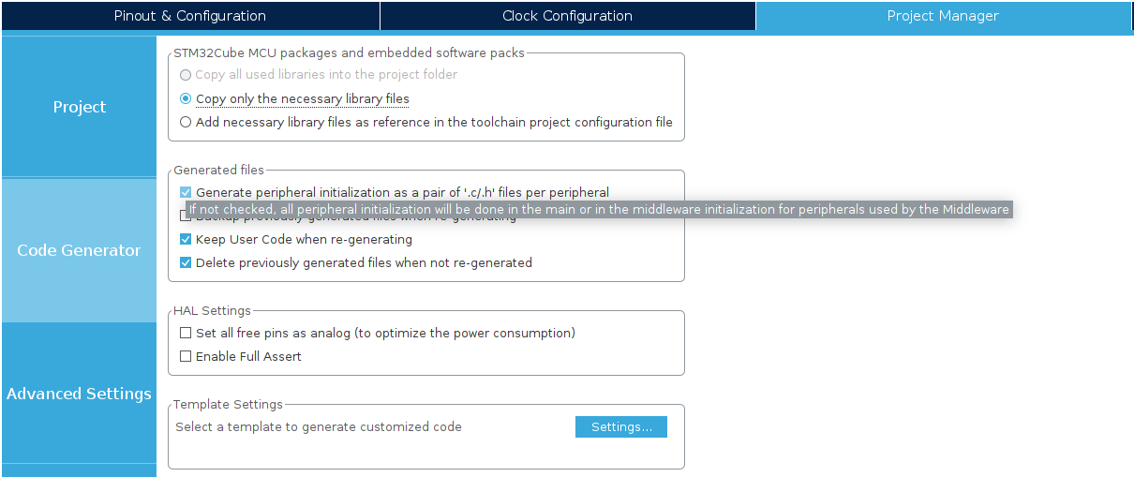

* SET THE LOW LAYER LIBRARY ON EVERY PERIPHERAL

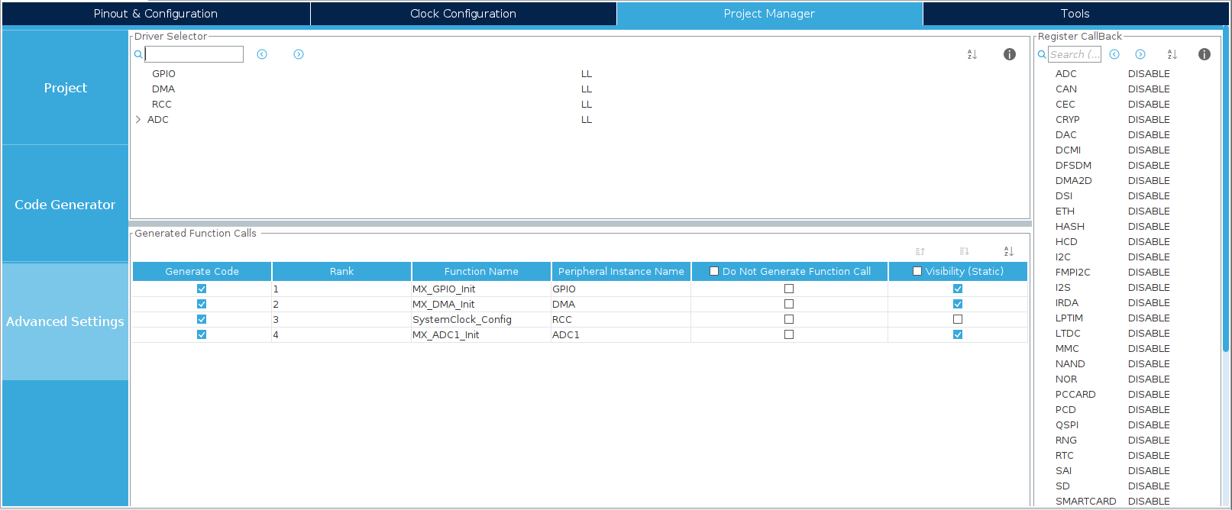

* AND FINALLY SAVE OR GENERATE THE CODE

